Area Border Routers: RT3, RT4, RT7, RT10, RT11

AS Boundary Routers: RT5, RT7
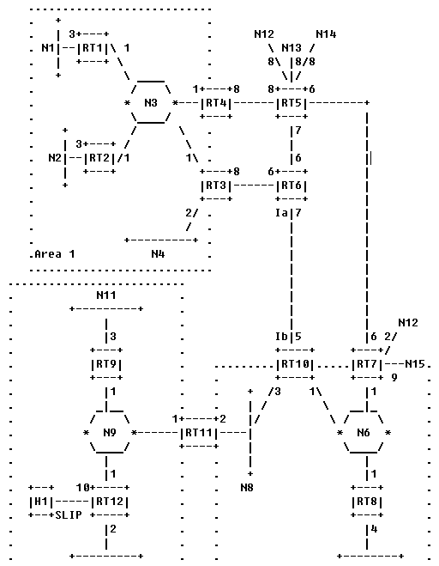
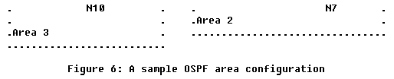
Virtual link
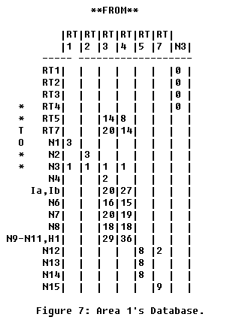
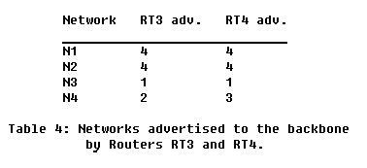
In area 1

AS boundary routers
In area 1
Summary link to network
External link
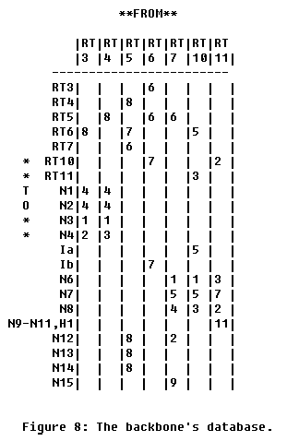
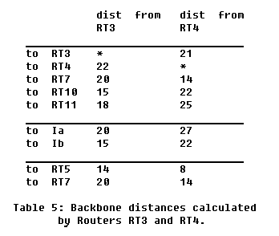
Routers in backbone area
Area 1’s summary
In backbone area
Area 2’s summary
Area 3’s summary
External link
Via SPF tree of the backbone

Summary link to AS boundary routers
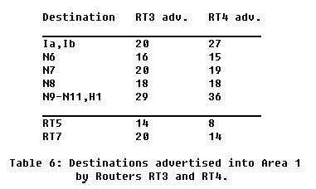
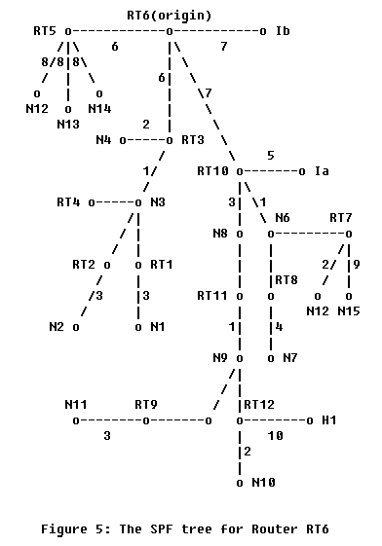
[Reference]: (without area configuration)
Summary link to network

